https://www.vultr.com/docs/install-and-configure-docker-swarm-on-ubuntu-20-04-lts/?utm_source=performance-max-apac&utm_medium=paidmedia&obility_id=16876059738&utm_adgroup=&utm_campaign=&utm_term=&utm_content=&gclid=Cj0KCQiA99ybBhD9ARIsALvZavVcdJ5HCDpDqtzIaJEDVBh781IIIKnxlu105Dtd4Ng4slbFrzVsISMaAkbaEALw_wcB

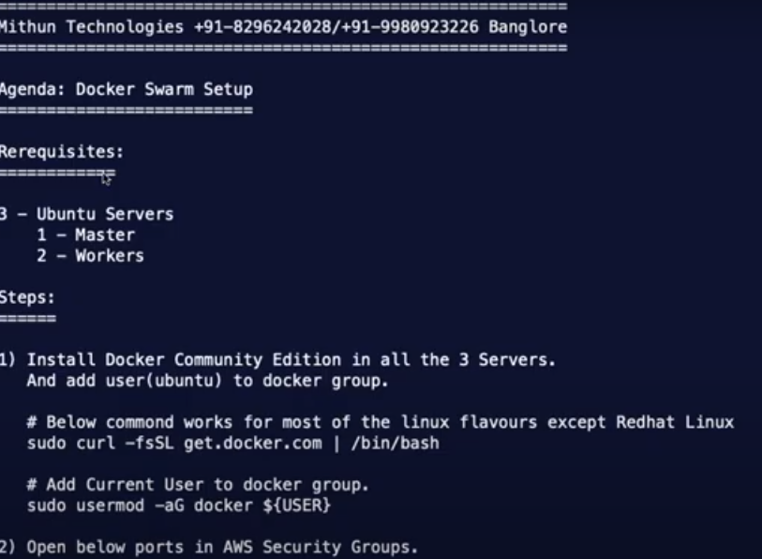

sudo curl –fssl get.docker.com | /bin/bash

sudo usermod –aG docker ${USER}

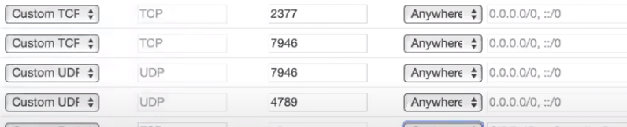

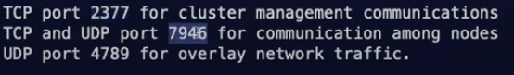

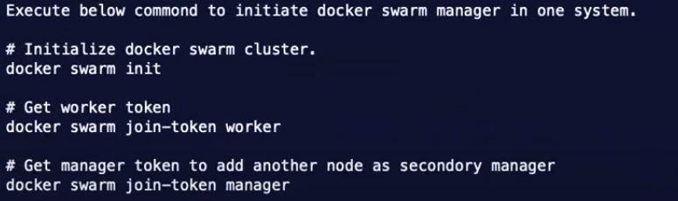

docker swarm Init

docker swarm join-token worker

docker swarm join-token manager

docker node ls

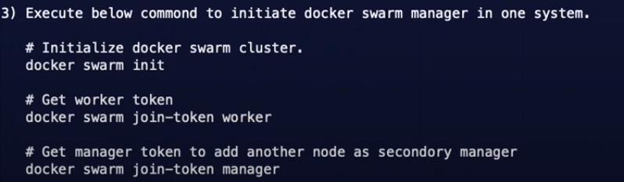

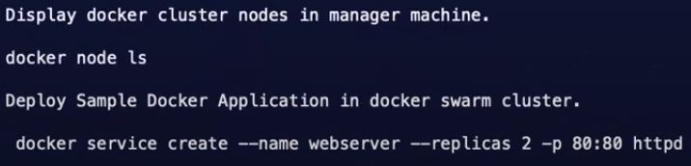

Docker service create –name webserver –-replicas 2 –p 80:80 httpd

Docker service ls

Docker service ps webserver

Now take the public ip of master along with port number we get the o/p from httpd